Week 5, Extension Exercises

# Exercise 1 – Temperature Converter GUI

Create a graphical application that allows a temperature to be converted from Fahrenheit to Celsius (Fig 1).

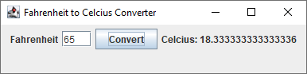

Fig – Fahrenheit to Celsius Converter GUI

The formula for converting Fahrenheit to Celsius is given below.

$$Celcius=\frac{5}{9}×\left(Fahrenheit-32\right)$$

# Exercise 2 – Rock Paper Scissors

Develop an application that allows a user to play “rock, paper, scissors” by pressing the appropriate button for the user’s move. You should generate a random move on behalf of the computer. You will need **3 JButton**s and **3** **JLabel**s. Fig 2 shows some example sessions of the program.

**Hints:**

* You could use an enumerated type to store both the valid *moves* of the game (rock, paper, scissors), and the different outcomes of the game for a user (win, lose, draw)

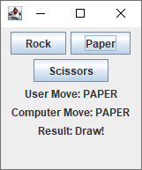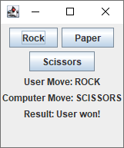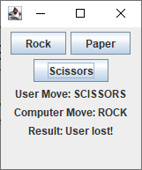

Fig - Rock, Paper, Scissors Example Sessions

# Exercise 3 – Guess the Number Game

Write a program that simulates a guessing game in a GUI program. Generate a secret random number between 1 and 100 (see hint below); that number is hidden from the user. Ask the user to guess a number between 1 and 100 in a text field, and then tell the user whether the number they guessed is too high, too low, or if the number is correct. Let the user continue to guess until the correct number is guessed. Fig 3 shows several example outputs of such a program.

**Hints**:

* A random number can be generated using the **Random** class from the **java.util** package, like below:

Random r = **new** Random(); // create an instance of the Random class

**int** randomNum = 1 + r.nextInt(100); // random num from 1 to 100 inclusive

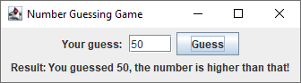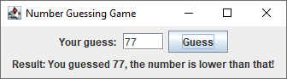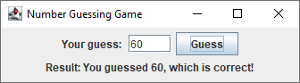

Fig 3 - Guessing Game Example Outputs